Café Sales Data Analysis Report

1. Goal
The objective of this project is to clean and preprocess the Dirty Café Sales dataset, addressing missing values, inconsistencies, and errors, and to create an interactive dashboard. This dashboard enables stakeholders to explore the café’s sales data, uncover trends, and support informed, data-driven decisions.

2. Executive Summary
This report analyzes the café’s sales data, highlighting strong revenue performance in key products alongside critical data integrity issues.

Key Findings
- Revenue Strength in Meals: Salad, Sandwich, and Smoothie generate over 50% of total revenue, with Salad ($5) as the top-grossing item.
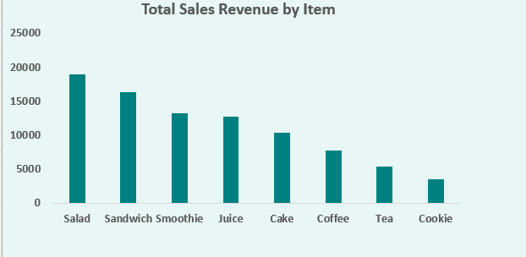
Fig: Visualization of Total Revenue by item
- High Stability: Monthly revenue remains consistent, ranging between approximately $6,650 and $7,334, indicating low seasonality.
- Critical Data Gaps: Nearly 40% of transactions have an unknown location, and over 31% have an unknown payment method, creating a significant blind spot.
- High-Value Risk: Transactions with unknown locations have an average spend slightly above the overall average, meaning missing data may disproportionately affect higher-value sales.

Required Action
A system-wide POS audit should be conducted immediately, with mandatory fields enforced and real-time validation implemented to close data gaps and ensure accurate operational and financial reporting.

3. Methodology (Data Preparation & Cleaning)

3.1 Initial Data Exploration & Validation
- Column Inspection: Checked data types, unique values, and missing/invalid entries.
- Item Column: Standardized invalid entries (UNKNOWN, ERROR, NaN) to 'unknown'.
- Numeric Columns: Temporarily replaced invalid values with -1 for Quantity, Price Per Unit, and Total Spent, and converted all to numeric types.
- Categorical Columns: Replaced missing or invalid entries with 'Unknown'.
This step ensured the dataset was structured correctly for further cleaning.

3.2 Data Imputation & Consistency Checks
- Price Imputation: Missing or invalid prices replaced with the most common price for that item.
- Item Imputation: Inferred 'unknown' items based on Price Per Unit using the most frequent mapping.
- Constraint Enforcement:
$$\text{Total Spent}=\text{Quantity}×\text{Price Per Unit}$$
- Missing Total Spent or Quantity was recalculated when possible; inconsistent or unsolvable records were removed.
- Persistent unknowns (Location, Payment Method) were retained as 'Unknown' to avoid bias.

3.3 Final Dataset Preparation
- Duplicate Check: Verified the dataset for duplicate transactions across all key fields.
- All retained records satisfy the financial constraint.
- Fully unknown or inconsistent records were removed.
- Columns retained:
['Transaction ID', 'Item', 'Quantity', 'Price Per Unit', 'Total Spent', 'Payment Method', 'Location', 'Transaction Date']
- Cleaned dataset exported as cleaned_data.csv.

3.4 Aggregation and Visualization
- Pivot Tables: Summarized key metrics by item, location, date, and payment method.
- Used DAX to calculate Ave_spent_per_transaction, enabling consistent measurement of average spending per transaction across items and categories.
- Dashboard Creation: Interactive visualizations include:
  - Sales Revenue by Item
  - Transactions by Channel and Payment Method
  - Transactions Over Time

4. Detailed Findings

4.1 Financial Performance and Product Mix
Top Revenue Drivers: Salad, Sandwich, and Smoothie account for 54.9% of total revenue $ 48799
Out of $ 88802
- Salad alone generates over $19,000 in sales.
- Price vs. Volume: Juice sells the most units (1,456), but high-priced items like Salad ($5) and Sandwich ($4) generate greater revenue.

4.2 Data Quality and Operational Gaps
- Location: 3,936 transactions (39.6%) are 'Unknown'.
- Payment Method: 3,155 transactions (31.7%) are 'Unknown'.
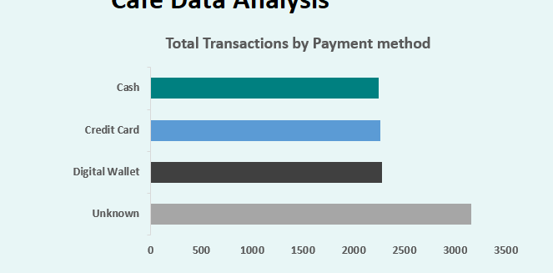 | 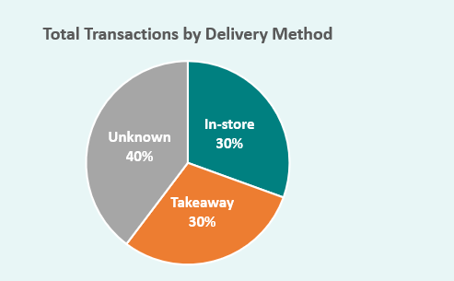

Fig: Visualization of locations and Payment Method

4.3 Business Stability and Transaction Channels
- High Stability: Monthly revenue ranges from $6,650 to $7,334, showing minimal seasonal variation. Note: These monthly totals are based on transactions with a known location (In-store and Takeaway) and exclude transactions with an Unknown location.
- Balanced Channels (Known Data):
  - In-store: 3,002 transactions
  - Takeaway: 3,005 transactions
- Payment Methods (Known Data):
  - Credit Card: 2,260
  - Cash: 2,250
  - Digital Wallet: 2,278

5. Recommendations

5.1 Improving Data Integrity
To address the high-risk data gaps:
- Review POS System: Identify why transactions default to 'Unknown'.
- Enforce Mandatory Fields: Require Payment Method and Location for every transaction.
- Real-Time Validation: Ensure Total Spent = Quantity × Price for all transactions by making it automated.
- Specific Error Codes: Replace generic placeholders with targeted error codes to aid auditing and staff training.

5.2 Strategic Focus
- Focus on High-Value Items: Emphasize Salad and Sandwich in marketing, menu placement, and inventory planning.
- Maximize Channel Insights: Once data gaps are resolved, analyze In-store vs. Takeaway profitability for better strategic decisions.
- Monitor Payment Methods: Use complete data to optimize infrastructure and customer experience.

5.3 Priority & Suggested Timing
Priority | Action | Responsible Party | Expected Impact
High | Review POS to find why transactions show 'Unknown' | IT / Operations | Reduces operational risk and missing data
High | Require Payment Method and Location for all transactions | IT / POS Vendor | Prevents future gaps, improves reporting
High | Add checks for Total Spent = Quantity × Price | IT / POS Vendor | Maintains financial accuracy
Medium | Replace generic errors with specific codes | IT / Operations | Supports focused auditing and staff training
Medium | Focus marketing/inventory on Salad & Sandwich | Marketing / Store Manager | Boosts revenue from high-value items
Medium | Analyze channel performance once data gaps are fixed | Business Analyst / Store Manager | Supports better strategic decisions
Low | Monitor payment trends and adapt processes | Finance / Operations | Ensures smooth transactions and customer experience

